MULTI BANKING APPLICATION
A Mini Project Report
Submitted In Fulfillment Of The Requirements
For The Award Of Degree Of
BACHELOR OF TECHNOLOGY
IN
COMPUTER SCIENCE AND ENGINEERING
By
V.UDAY KUMAR (13QH1A0557)
B.NAGARAJU (12QH1A0506)
P.BHANU CHANDER (13QH1A0535)
K.KALYANA KRISHNA (13QH1A0560)
Under The Estimated Guidance of
Prof. G. SOMA SEKHAR
Head Of The Department

DEPARTMENT OF COMPUTER SCIENCE AND ENGINEERING
HOLY MARY INSTITUTE OF TECHNOLOGY
(Approved by AICTE, New Delhi, Affiliated to JNTUH)Hyderabad-501301
MULTI BANKING APPLICATION
By
V.UDAY KUMAR (13QH1A0557)
B.NAGARAJU (12QH1A0506)
P.BHANU CHANDER (13QH1A0535)
K.KALYANA KRISHNA (13QH1A0560)

Guide
G. SOMA SEKHAR
Head Of The Department

DEPARTMENT OF COMPUTER SCIENCE AND ENGINEERING
HOLY MARY INSTITUTE OF TECHNOLOGY
(Approved by AICTE, New Delhi, Affiliated to JNTUH)
Bogaram (Vill), Keesara (Mndl), RangaReddy (Dist)-501301
2016-2017
HOLY MARY INSTITUTE OF TECHNOLOGY
(Approved by AICTE, New Delhi, Affiliated to JNTUH)
Hyderabad-500090
2016-2017
DEPARTMENT OF COMPUTER SCIENCE AND ENGINEERING

CERTIFICATE
This is to certify the Project report entitled “Multi Bank Application” is being submitted by the following student in partial fulfillment of the requirements for the award of degree of Bachelor of Technology in Computer Science and Engineering from Jawaharlal Nehru Technology University Hyderabad, Telangana is record of bonafide work carried out during the academic year 2016-2017.
V.UDAY KUMAR (13QH1A0557)
B.NAGARAJU (12QH1A0506)
P.BHANU CHANDER (13QH1A0535)
Y.KALYAN KRISHNA (13QH1A0560)

INTERNAL GUIDE HEAD OF THE DEPARTMENT
Prof. G.SOMA SEKHAR Prof. G.SOMA SEKHAR
Head Of The Department Head Of The Department
Department Of CSE Department Of CSE

EXTERNAL EXAMINER
ABSTRACT
Nowadays smart way of doing the work is very familiar among every business oriented enterprise application .We propose an enhanced smart multi-banking integrated using service oriented composition model by which using single username and password the user can able to access multiple account .This application integrates all existing banks and provides business solutions .This application acts as a standard interface between the clients and all the banks. Every user can have more than one bank accounts and each bank provides different username and passwords .To operate his/her account he/she wants to remember all the username and password of each bank .By using this portal any client who maintain accounts in various banks can directly log on to Multi Banking System Interface and make any kind of transactions. By using this interface client can also able to see all various bank accounts summaries in the single page. Even amount can be transacted between the bank in the single interface. Finally from the primary bank account user can withdraw the required amount. In the backend, system will take care of the entire obligation required in order to carry on transaction efficiently.

ACKNOWLEDGEMENT
It gives us a great sense of pleasure to present the report of the project undertaken during final year of B. Tech. We owe special debt of gratitude to Mr. G. Soma Sekhar, Head of Department, Computer Science & Engineering, Holy Mary Institute of Technology, Hyderabad for his constant support and guidance throughout the course of our work. It is only his cognizant efforts that our endeavors have seen light of the day.
We take this opportunity to acknowledge the contribution of Professor Mr. G. Soma Sekhar, Department of Computer Science & Engineering, for their full support and assistance during the development of the project.
We would like to express our special thanks to our Principal Dr. B S Reddappa for moral support and Management of Holy Mary Institutions of Technology, Hyderabad for providing us infrastructure to complete the project.
We also like to express our gratitude towards our parents/guardians & siblings for their kind co-operation and encouragement which helped us in completion of this project.
We do not want to miss the opportunity to acknowledge the contribution of all faculty members of the department for their kind assistance and cooperation during the development of our project. Last but not the least, we acknowledge our friends for their contribution in the completion of the project.

V. Uday Kumar 13QH1A0557
B. Nagaraju 12QH1A0506
P. Bhanu Chander 13QH1A0535
Y. Kalyana Krishna 13QH1A0560
INDEX
1. INTRODUCTION
2. LITERATURE SURVEY
2.1 Introduction
2.2 Existing System
2.3 Proposed System
3. REQUIREMENT SPECIFICATIONS
3.1 Introduction
3.2 Requirements Specification
3.3 Functional Requirement
3.4 Non-Functional Requirement
4. DESIGN
4.1 UML Diagrams
5. IMPLEMENTATION
5.1 Technology Used
6. CODING
6.1 Customer Registration Code
6.2 Banker Registration Code
6.3 Login Code
6.4 Customer Profile Code
6.5 Self Transaction Code
6.6 Transaction to Other Accounts Code
6.7 Add Bank Code
7. TESTING
8. OUTPUTS
9. CONCLUSION
10. SCOPE AND FUTURE ENHANCEMENT
11. BIBILIOGRAPHY

LIST OF FIGURES

Name of the figure
1. Admin Use case Diagram
2. Banker Use case Diagram
3. Customer Use case Diagram
4. Class Diagram
5. Sequence Diagram
6. Collaboration Diagram
7. Admin Activity Diagram
8. Banker Activity Diagram
9. Customer Activity Diagram

CHAPTER-1
INTRODUCTION
  - About Project:
The Multi Banking System Interface is targeted to the future banking solution for the users who is having multiple bank accounts in multiple banks. This interface integrates all existing banks and provides business solutions for both retail and corporate. This system acts as a standard interface between the clients and all the banks, By using this portal any client who maintain accounts in various banks can directly log on to Multi Banking System Interface and make any kind of transactions. In the backend, system will take care of the entire obligation required in order to carry on transaction smoothly.

2. LITERATURE SURVEY

2.1 INTRODUCTION
Nowadays smart way of doing the work is very familiar among every business oriented enterprise application .We propose an enhanced smart multi-banking integrated using service oriented composition model by which using single username and password the user can able to access multiple account .This application integrates all existing banks and provides business solutions .This application acts as a standard interface between the clients and all the banks. Every user can have more than one bank accounts and each bank provides different username and passwords .To operate his/her account he/she wants to remember all the username and password of each bank .By using this portal any client who maintain accounts in various banks can directly log on to Multi Banking System Interface and make any kind of transactions. By using this interface client can also able to see all various bank accounts summaries in the single page. Even amount can be transacted between the bank in the single interface. Finally from the primary bank account user can withdraw the required amount. In the backend, system will take care of the entire obligation required in order to carry on transaction efficiently.
2.1 EXISTING SYSTEM:
There are many Banking Applications available in today’s market but, these Multi Banking Application can be used for multi banking with different bank accounts in single application. There is no particular application for doing banking and transactions with different bank accounts.
Existing system with drawbacks:
Currently we are having lot of banks in the market and any person can do transactions of any individual bank either manually or in online. But no one can do all banks transactions in a single portal or in single bank. This is the main disadvantage in existing system to avoid this problem we are introducing “Multi Banking System”.

2.2 PROPOSED SYSTEM:
The Multi Banking System Interface is targeted to the future banking solution for the users who is having multiple bank accounts in multiple banks. This interface integrates all existing banks and provides business solutions for both retail and corporate.
This system acts as a standard interface between the clients and all the banks, By using this portal any client who maintain accounts in various banks can directly log on to Multi Banking System Interface and make any kind of transactions. In the backend, system will take care of the entire obligation required in order to carry on transaction smoothly.
FEATURES:
- Customer complete profile Management.
- Banker complete Profile Management.
- Different Bank Transaction details.
- Different Bank Balance details.

3. REQUIREMENT SPECIFICATION

3.1 SOFTWARE AND HARDWARE REQUIRMENTS
Software specifications of the system that is used in the project is
- Operating system: WINDOWS 8.1
- Front end: MICROSOFT VISUAL STUDIO 2012: Microsoft Visual Studio is an Integrated Development Environment from Microsoft .It can be used to develop console and graphical user interface applications along with windows forms applications , websites, web applications and web services in both native code together with managed code for all platforms supported by Microsoft Windows,.NET framework,.NET compact Framework and Microsoft Silver light .It also supports the C# that we use to create web site.
- Back end: SQL SERVER 2008 R2: In this SQL Server Management Studio is a software application first launched with the Microsoft SQL Server 2008 that is used for configuring, managing, and administering all components with in Microsoft SQL Server.
- Microsoft Office Word 2013: We use Microsoft Office Word 2013 to do our documentation of this project. This is very important for us to do this project. We have use the feature of text box to draw the hierarchical chart to describe the various of subsystem, modules and sub-modules in the system. It also uses to check our spelling and grammar and justify all the words to make our document look nicer.
Hardware Requirements:
• Processor : INTEL P4 or above
• Hard Disk : 40 GB.
• RAM : 2 GB
• Processor Speed : 1.54 GHZ

3.2Functionality Requirements
Functional requirements are associated with specific functions; tasks or behaviors the system must support. The functional requirements address the quality characteristic of functionality while the other quality characteristics are concerned with various kinds of non-functional requirements. Because non-functional requirements tend to be stated in terms of constraints on the results of tasks which are given as functional requirements (e.g., constraints on the speed or efficiency of a given task), a task-based functional requirements statement is a useful skeleton upon which to construct a complete requirements statement. That is the approach taken in this work. It can be helpful to think of non-functional requirements as adverbially related to tasks or functional requirements:
3.3Non-Functional Requirements:
Non-functional requirements are requirements that specify criteria that can be used to judge the operation of a system, rather than specific behaviors. This should be contrasted with functional requirements that specify specific behavior or functions. In general, functional requirements define what a system is supposed to do whereas non-functional requirements define how a system is supposed to be. Non-functional requirements are often called qualities of a system. Other terms for non-functional requirements are "constraints", "quality attributes", "quality goals" and "quality of service requirements". Qualities, aka. Non-functional requirements, can be divided into two main categories .Execution qualities, such as security and usability, are observable at run time. Evolution qualities, such as testability, maintainability, extensibility and scalability, are embodied in the static structure of the software system.
Reliability:
The services provided by our application are reliable, we ensure privacy to the documents uploaded by the users and they are only used for the purpose of verification.
Extensibility:
The application is widely extensible, where we have included services like the login id to check the message in the profile in case of loss of the messages or mobiles. Also many call routing mechanisms can be included.
Efficiency:
The system functions in an efficient manner with proper acknowledgements and responses at high speed.

4. DESIGN
4.1 UML DIAGRAMS
The Unified Modeling Language (UML) is a graphical language for visualizing, specifying, constructing and documenting of a software intensive system. The UML gives a standard way to standard way to write a system blueprints, covering conceptual things, such as classes written in a specified programmed language, database schemas and reusable software components.
There are types of diagrams
- Class Diagram
- Object Diagram
- Use case Diagram
- Sequence Diagram
- Collaboration Diagram
- State chart Diagram
- Activity Diagram
- Component Diagram
- Deployment Diagram

4.1.1 Use Case Diagram
- Use case is a description of set of sequence of actions that a system performs that yields an observable results. These are important in organizing the behaviors of a system.
- Use case is used to structure the behavioral things in a model.
- A Use case is realized by collaboration.
- Graphically , a use case is rendered as a ellipse with solid lines, usually including only its name
ACTOR- also referred to as roles. Name and stereotype of an actor can be changed in its properties lab
Use Cases- these can have extension points.

4.1.2 CLASS DIAGRAM
The class diagram is a static diagram. It represents the static view of an application. Class diagram is not only used for visualizing, describing documenting different aspects of a system but also for constructing executable code of the software application. The class diagram describes the attributes and operations of a class and also the constraints imposed on the system. The class diagrams are widely used in the modeling of object oriented system because they are the only UML diagrams which can be mapped directly with object oriented languages.
The class diagram shows a collection of classes, interfaces, associations, collaboration and constraints. It is also known as structural diagram.

4.1.3 SEQUENCE DIAGRAM:
A Sequence diagram is an interaction diagram that emphasizes the time ordering of messages. A Sequence diagram shows a set of objects and messages sent and received by those objects. The objects are typically named or anonymous instances of classes, but may also represent instances of other thing such as collaboration, components and nodes. These are used to illustrate the dynamic view of a system. It is isomorphic, which means taking any one of them in to consideration, and can be transformed to another.
A Sequence diagram shows, as parallel vertical lines (Life lines), a different processes or objects that live simultaneously, and as horizontal arrows, the messages exchanged between them, in the in which they occur. This allows the specification of simple runtime scenarios in a graphical manner. In order to show the sequence of time ordering of messages involved in the working of PHC a sequence diagram was used.
4.1.4 COLLABORATION DIAGRAM
A Collaboration diagram is an interaction diagram that emphasizes the structural organization of the objects that send and receive messages. Collaboration diagrams are isomorphic, meaning that you can take one and transform it in to another
Graphically, collaboration is rendered as an ellipse with dashed lines, usually including only its name
4.1.5 ACTIVITY DIAGRAMS:
Activity diagrams are graphical representations of work flows of stepwise activities and actions with support for choice, iteration and concurrency. In the Unified Modeling Language, activity diagrams are intended to model both computational and organizational processes. Activity diagrams show the overall flow of control.

CHAPTER-5
IMPLEMENTATION

It is the process of bringing developed system of revised system into operational use. Ifthe implementation phase is not carefully planned and controlled, it can lead to many problems. Thus proper implementation is essential to provide a reliable system to meet managerial requirements.
The application is completely written .net .This integrates all existing bank and provides business solutions. This application acts as standard interface between the customers and all the banks. We use sql server as a back end for storing database.
5.1: TECHNOLOGY USED:
5.1.1: Dot Net:
The .NET Framework (pronounced dot net) is a proprietary, partially open source freeware software framework developed by Microsoft that runs primarily on Microsoft Windows.
5.1.2: What is Dot Net?
The .NET is the technology from Microsoft, on which all other Microsoft technologies will be depending on in future. It is a major technology change, introduced by Microsoft, to catch the market from the SUN's Java. Few years back, Microsoft had only VC++ and VB to compete with Java, but Java was catching the market very fast. With the world depending more and more on the Internet/ Web and java related tools becoming the best choice for the web applications, Microsoft seemed to be losing the battle. Thousands of programmers moved to java from VC++ and VB. To recover the .market, .Microsoft announced .NET.
But Microsoft has a wonderful history of starting late but catching up quickly. This is true in case of .NET too. Microsoft put their best men at work for a secret project called Next Generation Windows Services (NGWS)., under the direct supervision of Mr. Bill Gates.
The outcome of the project is what we now know as .NET. Even though .NET has borrowed most of its ideas from Sun's J2EE, it has really outperformed their competitors.
Microsoft's VC++ was a powerful tool. But it was too complex. It has too many data types, and developers had to learn many libraries including Windows SDK, MFC, ATL, COM etc. There were many data type compatibility issues while exchanging data between different layers. Visual Basic was too easy, and many serious programmers hated it just for that reason. Even though Visual basic was very easy to use, it was not very flexible to develop serious applications. SUN's Java became a very good choice for these reasons. It had the flexibility and power of C++ and at the same time easy enough to catch the attention of VB programmers.

5.1.3: The structure of Dot Net:
- It is a platform for application developers.
- It is a Framework that supports Multiple Language and Cross language integration.
- IT has IDE (Integrated Development Environment).
- Framework is a set of utilities or can say building blocks of your application system.
- .NET Framework provides GUI in a GUI manner.
- .NET is a platform independent but with help of Mono Compilation System (MCS). MCS is a middle level interface.
- .NET Framework provides interoperability between languages i.e. Common Type System (CTS).
- .NET Framework also includes the .NET Common Language Runtime (CLR), which is responsible for maintaining the execution of all applications developed using the .NET library.

The .NET Framework consists primarily of a gigantic library of code.

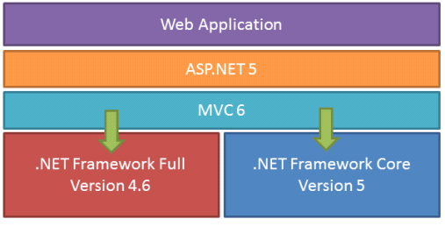

Class Library:
.NET Framework includes a set of standard class libraries. The class library is organized in a hierarchy of namespaces. Most of the built-in APIs are part of either system or Microsoft namespaces. These class libraries implement a large number of common functions, such as file reading and writing, graphic rendering, database interaction, and XML document manipulation, among others. .NET class libraries are available to all CLI compliant languages. .NET Framework class library is divided into two parts: Framework Class Library (FCL) and Base Class Library (BCL).
FCL includes a small subset of the entire class library and is the core set of classes that serve as the basic API of CLR. Classes in and some classes.inSystem.dll and System.core.dll are part of FCL. FCL classes are available in .NET Framework as well as its alternative implementations including .NET Compact Framework, Microsoft Silverlight and Mono.
BCL is a superset of FCL and refers to the entire class library that ships with .NET Framework. It includes an expanded set of libraries, including Windows Forms, ADO.NET, ASP.NET, Language Integrated Query (LINQ), Windows Presentation Foundation (WPF), Windows Communication Foundation (WCF) and Workflow Foundation (WF). BCL is much larger in scope than standard libraries for languages like C++, and comparable in scope to standard libraries of Java.
.NET Core:
.NET Core is a free and open-source partial implementation of the .NET Framework. It consists of CoreCLR and CoreFX, which are partial forks of CLR and BCL respectively.NET Core comes with an improved JIT compiler, called RyuJIT.
Assemblies:
Compiled CIL code is stored in CLI assemblies. As mandated by the specification, assemblies are stored in Portable Executable (PE) file format, common on Windows platform for all DLL and EXE files. Each assembly consists of one or more files, one of which must contain a manifest bearing the metadata for the assembly. The complete name of an assembly (not to be confused with the file name on disk) contains its simple text name, version number, culture, and public key token. Assemblies are considered equivalent if they share the same complete name, excluding the revision of the version number.
A private key can also be used by the creator of the assembly for strong naming. The public key token identifies which private key an assembly is signed with. Only the creator of the keypair(typically .NET developer signing the assembly) can sign assemblies that have the same strong name as a previous version assembly, since the creator is in possession of the private key. Strong naming is required to add assemblies to Global Assembly Cache.
C++/CLI:
Microsoft introduced C++/CLI in Visual Studio 2005, which is a language and means of compiling Visual C++ programs to run within the .NET Framework. Certain portions of the C++ program still run within an unmanaged Visual C++ Runtime, while specially modified portions are translated into CIL code and run with the .NET Framework's CLR.
Assemblies compiled using the C++/CLI compiler are known as mixed-mode assemblies, since they contain native and managed code within the same DLL, Such assemblies are also difficult to reverse engineer, since .NET de compilers such as .NET Reflector only reveal the managed code.

Security:
.NET Framework has its own security mechanism with two general features: Code Access Security (CAS), and validation and verification. CAS is based on evidence that is associated with a specific assembly. Typically the evidence is the source of the assembly (whether it is installed on the local machine or has been downloaded from the intranet or Internet). CAS uses evidence to determine the permissions granted to the code. Other code can demand that calling code be granted a specified permission. The demand causes CLR to perform a call stack walk: every assembly of each method in the call stack is checked for the required permission; if any assembly is not granted the permission a security exception is thrown.
Managed CIL byte code is easier to reverse-engineer than native code, unless obfuscated. NET decompile programs enable developers with no reverse-engineering skills to view the source code behind unobfuscated .NET assemblies. In contrast, apps compiled to native machine code are much harder to reverse-engineer and source code is almost never produced successfully, mainly because of compiler optimizations and lack of reflection. One concern is over possible loss of trade secrets and the bypassing of license control mechanisms. To mitigate this, Microsoft has included Dotfuscator Community Edition with Visual Studio .NET since 2002.^{[b]} Third-party obfuscation tools are also available from vendors such as vmware, V.i. Labs, Xenocode, Red Gate Software. Method-level encryption tools for .NET code are available from vendors such as Safe Net.

Memory management:
CLR frees the developer from the burden of managing memory (allocating and freeing up when done); it handles memory management itself by detecting when memory can be safely freed. Instantiations of .NET types (objects) are allocated from the managed heap; a pool of memory managed by CLR. As long as there exists a reference to an object, which might be either a direct reference to an object or via a graph of objects, the object is considered to be in use. When there is no reference to an object, and it cannot be reached or used, it becomes garbage, eligible for collection.
.NET Framework includes a garbage collector (GC) which runs periodically, on a separate thread from the application's thread, that enumerates all the unusable objects and reclaims the memory allocated to them. It is a non-deterministic, compacting, mark-and-sweep garbage collector. GC runs only when a certain amount of memory has been used or there is enough pressure for memory on the system. Since it is not guaranteed when the conditions to reclaim memory are reached, GC runs are non-deterministic. Each .NET application has a set of roots, which are pointers to objects on the managed heap (managed objects). These include references to static objects and objects defined as local variables or method parameters currently in scope, as well as objects referred to by CPU registers. When GC runs, it pauses the application, and for each object referred to in the root,it recursively enumerates all the objects reachable from the root objects and marks them as reachable. It uses CLI metadata and reflection to discover the objects encapsulated by an object, and then recursively walk them. It then enumerates all the objects on the heap (which were initially allocated contiguously) using reflection. All objects not marked as reachable are garbage. This is the mark phase. Since the memory held by garbage is not of any consequence, it is considered free space. However, this leaves chunks of free space between objects which were initially contiguous. The objects are then compacted together to make used memory contiguous again. Any reference to an ect invalidated by moving the object is updated by GC to reflect the new location. The application is resumed after the garbage collection is over.
GC used by .NET Framework is also generational. Objects are assigned a generation; newly created objects belong to Generation 0. The objects that survive a garbage collection are tagged as Generation 1, and the Generation 1 objects that survive another collection are Generation 2 objects. .NET Framework uses up to Generation 2 objects. Higher generation objects are garbage collected less frequently than lower generation objects. This helps increase the efficiency of garbage collection, as older objects tend to have a longer lifetime than newer objects. Thus, by eliminating older (and thus more likely to survive a collection) objects from the scope of a collection run, fewer objects need to be checked and compacted.

Performance:
When an application is first launched, the .NET Framework compiles the CIL code into executable code using its just-in-time compiler, and caches the executable program into the .NET Native Image Cache. Due to caching, the application launches faster for subsequent launches, although the first launch is usually slower. To increase speed of the first launch, developers may use the Native Image Generator utility to manually compile and cache any .NET application, ahead-of-time.
The garbage collector, which is integrated into the environment, can introduce unanticipated delays of execution over which the developer has little direct control. "In large applications, the number of objects that the garbage collector needs to deal with can become very large, which means it can take a very long time to visit and rearrange all of them.
.NET Framework provides support for calling Streaming SIMD Extensions (SSE) via managed code from April 2014 in Visual Studio 2013 Update 2. However, Mono has provided support for SIMD Extensions as of version 2.2 within the Mono. Simd namespace; before. Mono's lead developer Miguel de Icaza has expressed hope that this SIMD support will be adopted by CLR's ECMA standard.Streaming SIMD Extensions have been available in x86 CPUs since the introduction of the Pentium III. Some other architectures such as ARM and MIPS also have SIMD extensions. In case the CPU lacks support for those extensions, the instructions are simulated in software.

CHAPTER 6
CODING
6.1 Customer Register Code
using System;
using System.Collections.Generic;
using System.Linq;
using System.Web;
using System.Web.UI;
using System.Web.UI.WebControls;

publicpartialclassCustomerReg : System.Web.UI.Page
{
protectedvoid Page_Load(object sender, EventArgs e)
{

}
Class1 obj = newClass1();

protectedvoid ImageButton1_Click(object sender, ImageClickEventArgs e)
{
try
{

string qry = "insert into Customer values('" + txtfn.Text + "','" + txtln.Text + "','" + txtdob.Text + "','" + RadioButtonList1.SelectedItem.Text + "','" + txtadd.Text + "','" + txtemail.Text + "','" + txtpw.Text + "','" + txtmobile.Text + "','pending')";

int i = obj.InUpDel(qry);
if (i > 0)
{
Response.Write("<script>alert('Registration Sucessfully Completed')</script>");
txtfn.Text = txtln.Text = txtadd.Text = txtdob.Text = txtmobile.Text = txtpw.Text = txtemail.Text= " ";
}
else
{
Response.Write("<script>alert('Not Yet Registerds')</script>");
}
}
catch (Exception ex)
{

Response.Write("<script>alert('" + ex.Message + "')</script>");
}

}
}
6.2 Banker Register code
using System;
using System.Collections.Generic;
using System.Linq;
using System.Web;
using System.Web.UI;
using System.Web.UI.WebControls;

publicpartialclassBankerReg : System.Web.UI.Page
{
protectedvoid Page_Load(object sender, EventArgs e)
{

}
Class1 obj = newClass1();

protectedvoid ImageButton1_Click(object sender, ImageClickEventArgs e)
{

try
{

string qry = "insert into Banker values('" + txtfn.Text + "','" + txtln.Text + "','" + RadioButtonList1.SelectedItem.Text + "','" + txtadd.Text + "','" + DropDownList1.SelectedItem.Text + "','" + txtempid.Text + "','" + txtpw.Text + "','" + txtbankphone.Text + "','pending')";

int i = obj.InUpDel(qry);
if (i > 0)
{
Response.Write("<script>alert('Registration Sucessfully Completed')</script>");
txtfn.Text = txtln.Text = txtadd.Text = txtempid.Text = txtbankphone.Text = txtpw.Text = " ";
}
else
{
Response.Write("<script>alert('Not Yet Registerd')</script>");
}
}
catch (Exception ex)
{

Response.Write("<script>alert('" + ex.Message + "')</script>");
}

}
}
6.3 Login Code
using System;
using System.Collections.Generic;
using System.Linq;
using System.Web;
using System.Web.UI;
using System.Web.UI.WebControls;
using System.Data;
using System.Data.SqlClient;

publicpartialclasslogin : System.Web.UI.Page
{
protectedvoid Page_Load(object sender, EventArgs e)
{

}
Class1 obj = newClass1();
protectedvoid ImageButton1_Click(object sender, ImageClickEventArgs e)
{
try
{
if (DropDownList1.SelectedItem.Text == "Banker")
{
string qry = "select * from Banker where Firstname='" + txtun.Text + "' and Password='" + txtpw.Text + "' and Status ='Active'";
DataSet ds = obj.Display(qry);
if (ds.Tables[0].Rows.Count > 0)
{
Session["id"] = ds.Tables[0].Rows[0][0].ToString();
Session["Firstname"] = ds.Tables[0].Rows[0][1].ToString();
Session["bank"] = ds.Tables[0].Rows[0][5].ToString();
Response.Redirect("~/Banker/BankerHome.aspx");
}
else
{
Response.Write("<script>alert('Invalid Username Or Password!!')</script>");
}

}
elseif (DropDownList1.SelectedItem.Text == "Admin")
{
if (txtun.Text == "admin"&& txtpw.Text == "admin")
{
Response.Redirect("~/Admin/AdminHome.aspx");
}
else
{
Response.Write("<script>alret('Invalid Username Or Password!!')</script>");
}
}
elseif (DropDownList1.SelectedItem.Text == "Customer")
{

string qry = "select * from Customer where Firstname='" + txtun.Text + "' and Password='" + txtpw.Text + "' and Status ='Active'";
DataSet ds = obj.Display(qry);
if (ds.Tables[0].Rows.Count > 0)
{
Session["id"] = ds.Tables[0].Rows[0][0].ToString();
Session["Firstname"] = ds.Tables[0].Rows[0][1].ToString();
// Session["Password"] = ds.Tables[0].Rows[0][8].ToString();
Response.Redirect("~/Customer/CustomerHome.aspx");
}
else
{
Response.Write("<script>alret('Invalid Username Or Password!!')</script>");
}

}

}
catch (Exception ex)
{
Response.Write("<script>alert('" + ex.Message + "')</script>");

}

}
}

6.4 Customer Profile Code
using System;
using System.Collections.Generic;
using System.Linq;
using System.Web;
using System.Web.UI;
using System.Web.UI.WebControls;
using System.Data;
using System.Data.SqlClient;

publicpartialclassCustomer_CustomerProfile : System.Web.UI.Page
{

protectedvoid Page_Load(object sender, EventArgs e)
{

if (!IsPostBack)
{
load();

}

}
Class1 obj = newClass1();

publicvoid load()
{
try
{
string qry2 = "select * from Customer where CustomerId='" + Session["id"].ToString() + "'";
DataSet ds = obj.Display(qry2);
if (ds.Tables[0].Rows.Count > 0)
{
txtun.Text = ds.Tables[0].Rows[0][1].ToString();
txtdob.Text = ds.Tables[0].Rows[0][3].ToString();
txtadd.Text = ds.Tables[0].Rows[0][5].ToString();
txtemail.Text = ds.Tables[0].Rows[0][6].ToString();
txtpw.Text = ds.Tables[0].Rows[0][7].ToString();
txtmobile.Text = ds.Tables[0].Rows[0][8].ToString();

}
else
{
Response.Write("<script>alert('There is No Data')</script>");
}
}
catch (Exception ex)
{

Response.Write("<script>alert('" + ex.Message + "')</script>");
}
}

protectedvoid ImageButton1_Click(object sender, ImageClickEventArgs e)
{
try
{
string qry = "update Customer set Password='" + txtpw.Text + "',Mobile='" + txtmobile.Text + "',Address='" + txtadd.Text + "',Email='" + txtemail + "' where CustomerId='" + Session["id"].ToString() + "'";
int i = obj.InUpDel(qry);
if (i > 0)
{
Response.Write("<script>alert('Updated Succesfully')</script>");
}
}

catch (Exception ex)
{

Response.Write("<script>alert('" + ex.Message + "')</script>");
}
}

protectedvoid lbadd_Click(object sender, EventArgs e)
{
txtadd.ReadOnly=false;
}
protectedvoid lbemail_Click(object sender, EventArgs e)
{
txtemail.ReadOnly = false;
}
protectedvoid lbpw_Click(object sender, EventArgs e)
{
txtpw.ReadOnly = false;
}
protectedvoid lbmobile_Click(object sender, EventArgs e)
{
txtmobile.ReadOnly = false;
}
}
6.5 Self Transaction code
using System;
using System.Collections.Generic;
using System.Linq;
using System.Web;
using System.Web.UI;
using System.Web.UI.WebControls;
using System.Data;
using System.Data.SqlClient;

publicpartialclassCustomer_SelfTransfer : System.Web.UI.Page
{
protectedvoid Page_Load(object sender, EventArgs e)
{

}
Class1 obj = newClass1();
protectedvoid imgselect_Click(object sender, ImageClickEventArgs e)
{

try
{

string qry = "select * from Transcation where CustomerId='" + Session["id"].ToString() + "' and Bank='" + drpselect.SelectedItem.Text + "' and Accountno='" + txtaccno.Text + "'";
DataSet ds = obj.Display(qry);
if (ds.Tables[0].Rows.Count > 0)
{

double i = double.Parse(ds.Tables[0].Rows[0][4].ToString());
double j = double.Parse(txtamount.Text);
double z = i + j;
string qry1 = "update Transcation set Amount='" + z.ToString() + "' where CustomerId='" + Session["id"].ToString() + "' and Bank='" + drpselect.SelectedItem.Text + "' and Accountno='" + txtaccno.Text + "'";
int k = obj.InUpDel(qry1);
if (k > 0)
{
Response.Write("<script>alert('Added Sucessfully')</script>");
}

else
{
Response.Write("<script>alert('Not Yet Added')</script>");
}
txtaccno.Text = txtamount.Text = " ";
}

}
catch (Exception ex)
{

Response.Write("<script>alert('" + ex.Message + "')</script>");
}
}
}
6.6 Transaction To Other Account Code
using System;
using System.Collections.Generic;
using System.Linq;
using System.Web;
using System.Web.UI;
using System.Web.UI.WebControls;
using System.Data;
using System.Data.SqlClient;

publicpartialclassCustomer_OtherTransfer : System.Web.UI.Page
{
protectedvoid Page_Load(object sender, EventArgs e)
{

}
Class1 obj = newClass1();
protectedvoid imgsubmit_Click(object sender, ImageClickEventArgs e)
{
try
{
string qry = "select * from Transcation where Accountno='" + txtfromaccount.Text + "'";
DataSet ds = obj.Display(qry);
double d1 = double.Parse(ds.Tables[0].Rows[0][4].ToString());
string qry1 = "select * from Transcation where Accountno='" + txttoaccount.Text + "'";
DataSet ds1 = obj.Display(qry1);
double d2 = double.Parse(ds1.Tables[0].Rows[0][4].ToString());
double d3 = double.Parse(txtamount.Text);
if (d1 > d3)
{
string qry2 = "insert into Other values('"+ddlsb.SelectedItem.Text+"','" + txtfromaccount.Text + "','" + txttoaccount.Text + "','" + txtamount.Text + "')";
int i = obj.InUpDel(qry2);
if (i > 0)
{
double d4 = d1 - d3;
double d5 = d2 + d3;
string qry3 = "update Transcation set Amount='" + d4.ToString() + "' where Accountno='" + txtfromaccount.Text + "'";
int j = obj.InUpDel(qry3);
if (j > 0)
{
Response.Write("<script>alert('Amount Debited Sucessfully')</script>");
string qry4 = "update Transcation set Amount='" + d5.ToString() + "' where Accountno='" + txttoaccount.Text + "'";
int k = obj.InUpDel(qry4);

if (k > 0)
{
Response.Write("<script>alert('Amount Credited Sucessfully')</script>");
}
else
{
Response.Write("<script>alert('Amount Not Credited')</script>");
}
}
else
{
Response.Write("<script>alert('Amount Not Credited')</script>");
}
}
else
{
Response.Write("<script>alert('Transcation Failed ')</script>");
}
}
else
{
Response.Write("<script>alert('You Don't have Sufficent Amount To Transfer')</script>");
}
txttoaccount.Text = txtamount.Text = txttoaccount.Text = "";
}

catch (Exception ex)
{

Response.Write("<script>alert('" + ex.Message + "')</script>");
}

}
protectedvoid ddlsb_SelectedIndexChanged(object sender, EventArgs e)
{
string qry5 = "select * from Transcation where Bank='" + ddlsb.SelectedItem.Text + "' and CustomerId='" + Session["id"].ToString() + "'";
DataSet ds = obj.Display(qry5);
txtfromaccount.Text = ds.Tables[0].Rows[0][3].ToString();
}
}
6.7 Add Bank Code
using System;
using System.Collections.Generic;
using System.Linq;
using System.Web;
using System.Web.UI;
using System.Web.UI.WebControls;
using System.Data;
using System.Data.SqlClient;

publicpartialclassCustomer_AddBank : System.Web.UI.Page
{
protectedvoid Page_Load(object sender, EventArgs e)
{

}
Class1 obj = newClass1();
protectedvoid ImageButton1_Click(object sender, ImageClickEventArgs e)
{
try
{

string qry = "insert into Addbank values('"+Session["id"].ToString()+"','" + DropDownList1.SelectedItem.Text + "','" + txtaccno.Text + "','" + txtacchname.Text + "','" + txtcustid.Text + "')";

int i = obj.InUpDel(qry);
if (i > 0)
{
Response.Write("<script>alert('Added Sucessfully')</script>");
string qry1 = "insert into Transcation values('" + Session["id"].ToString() + "','" + DropDownList1.SelectedItem.Text + "','" + txtaccno.Text + "','0')";
int j = obj.InUpDel(qry1);
if (j > 0)
{
// Response.Write("<script>alert('Added successfully')");
string message = "alert('answered')";
ScriptManager.RegisterClientScriptBlock((sender asControl), this.GetType(), "alert", message, true);
}
else
{
Response.Write("<script>alert('Not Yet Added')</script>");
}
txtaccno.Text = txtacchname.Text = txtcustid.Text= " ";
}
else
{
Response.Write("<script>alert('Not Yet Added')</script>");
}
}
catch (Exception ex)
{

Response.Write("<script>alert('" + ex.Message + "')</script>");
}
}
protectedvoid ImageButton2_Click(object sender, ImageClickEventArgs e)
{
txtaccno.Text = txtacchname.Text = txtcustid.Text = " ";
}
}

7 TESTING

7.1 Introduction:
The purpose of testing is to discover errors in the system. Testing is the process of trying to discover every conceivable fault or weakness in a system by implementing using testing strategies. A process of executing a program with the explicit intention of finding errors, that is making the program fail. Testing is the process of detecting errors. Testing performs a very critical role for quality assurance and for ensuring the reliability of software. The results of testing are used later on during maintenance also. Psychology of Testing.
The aim of testing is often to demonstrate that a program works by showing that it has no errors. The basic purpose of testing phase is to detect the errors that may be present in the program. Hence one should not start testing it the intent of showing that a program works but the intent should be to show that a program does not work. Testing is a process of executing a program in order to find out the errors in the program.

7.2 TESTING STRATEGIES:
In order to make sure that the system does not have errors, the different levels of testing strategies that are applied at differing phases of software development are:
1. Unit Testing
2. Integration Testing
3. Validation Testing
4. System Testing

7.2.1 UNIT TESTING:
Unit Testing is done on individual modules in our project as they are completed and become executable. It is confined only to the designer's requirements.
Each module can be tested using the following two Strategies:

Black Box Testing:
In our system the black box testing can be implemented by testing the compilation and run-time errors.

White Box testing:
In our system the test-cases for each case are generated on the logic of each module by drawing flow graphs of that module and logical decisions are tested on all the cases. White box testing has been:
- Every logical decision is found by checking the validations “please enter valid password” “enter valid details”.
- In our project the each if loop is checked weather it is satisfying its needs.

7.2.2 INTEGRATION TESTING:
Software integration testing is the incremental integration testing of two or more integrated software components on a single platform to produce failures caused by interface defects. The task of the integration test is to check that components or software applications, e.g. components in a software system or – one step up – software applications at the company level – interact without error.

7.2.3 VALIDATION TESTING:
The system can be validated; whenever the input is given into the system it checks the validations for each module.Since, our system has been tested and implemented successfully and thus ensured that all the requirements as listed in the software requirements specification are completely fulfilled. In case of erroneous input corresponding error messages are displayed.
- Enter the correct password.
- Enter the valid details.
- Fill all the fields etc.
7.2.4 SYSTEM TESTING:
At last our system is tested that each module is checked before delivery to the user. Our aim is to satisfy the user the system meets all requirements of the client's specifications.
7.3 TEST CASES:
The test-cases are used to validate the each module every time whenever user enters the input into the system then we can provide the results either pass or fail with expected result and actual result. Clinically defined (IEEE 829-1998) a test case is an input and an expected result. This can be as pragmatic as 'for condition x your derived result is y', whereas other test cases described in more detail the input scenario and what results might be expected. It can occasionally be a series of steps (but often steps are contained in a separate test procedure that can be exercised against multiple test cases, as a matter of economy) but with one expected result or expected outcome. The optional fields are a test case ID, test step or order of execution number, related requirement(s) depth, test category, author, and check boxes for whether the test is automatable and has been automated. Larger test cases may also contain prerequisite states or steps, and descriptions. A test case should also contain a place for the actual result. These steps can be stored in a word processor document, spreadsheet, database or other common repository. In a database system, you may also be able to see past test results and who generated the results and the system configuration used to generate those results. These past results would usually be stored in a separate table.
Test Case Reports:
Test 1:
TEST CASES | EXPECTED OUTPUT | ACTUAL OUTPUT |  | CONDITION
Registration | Registration Successfully | Registration successfully |  | Pass
Login | Login successfully | Login successfully |  | Pass
Customer Self Transaction | Transaction successfully | Transaction Successful |  | Pass
Other Transaction | Transaction successfully | Transaction successfully |  | Pass
Customer Profile Update | Profile Updated successfully | Profile Updated successfully |  | Pass
Add Bank | Bank Added successfully |  | Bank Added successfully | Pass
Customer Request | Customer Request Accepted |  | Customer Request Accepted | Pass
Banker Request | Banker Request Accepted |  | Banker Request Accepted | Pass

Table: 7.7.1 Positive Test Cases for Multi Banking Application of.NET documents

Test 2:
TEST CASES | EXPECTED OUTPUT |  | ACTUAL OUTPUT | CONDITION
Registration | Registration successfully |  | Registration Failed | Fail
Login | Login successfully |  | Invalid Username or Password Failed | Fail
Customer Self Transaction | Transaction successfully |  | Transaction Failed | Fail
Other Transaction | Transaction successfully |  | Transaction Failed | Fail
Update Profile | Profile Updated successfully |  | Profile Not Yet Updated | Fail
Add Bank | Bank Added successfully | Not Yet Added |  | Fail
Customer Request | Customer Request Accepted | Customer Request Rejected |  | Fail
Banker Request | Banker Request Accepted | Banker Request Rejected |  | Fail

Table: 7.7.2 Negative Test Cases for a Multi Banking Application for .NET documents

All the above validations on table have verified and they are successfully executed. The flow is tested in different possible conditions of testing stages and all conditions are modified when the condition failed in the process of testing stage and all the bugs in application has modified in the testing.

CHAPTER 8
OUTPUTS
8.1 Home Page:
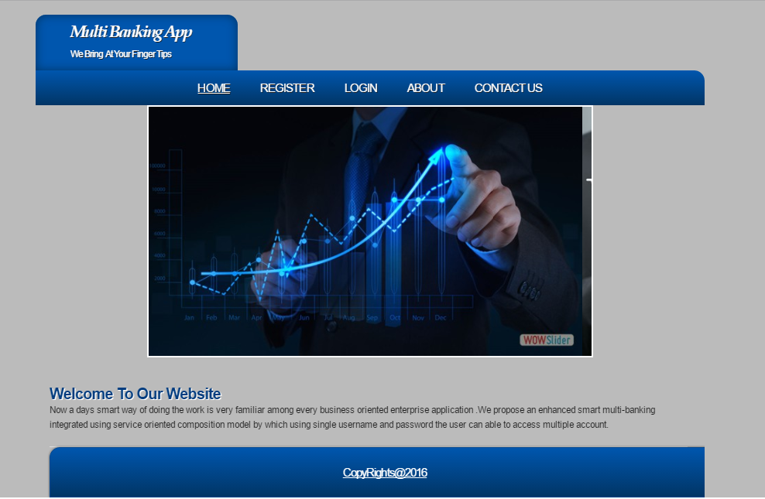
Fig 8.1 Home Page

8.2 Customer Registration Page

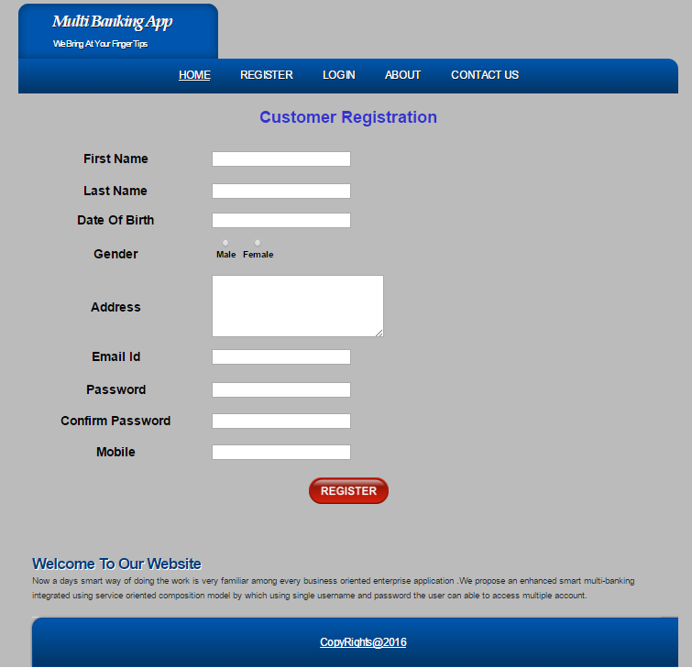
Fig: 8.2 Customer Registration

8.3 Banker Registration Page:

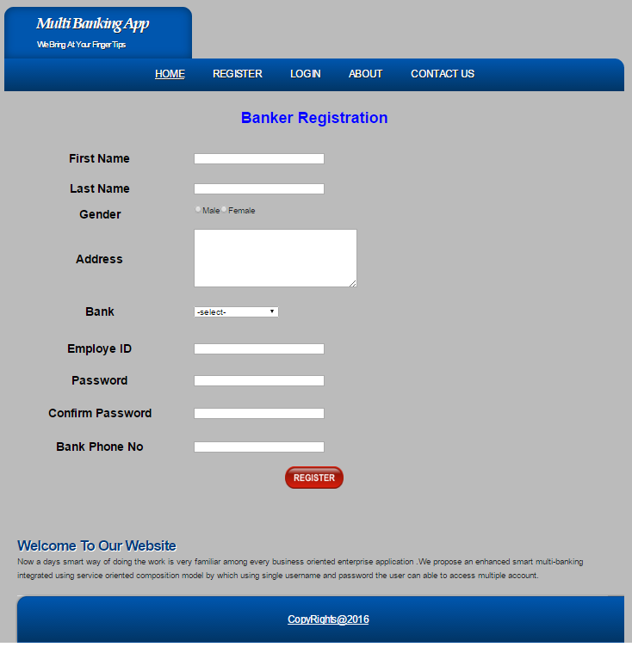
Fig: 8.3 Banker Registration

8.4 Login Page:

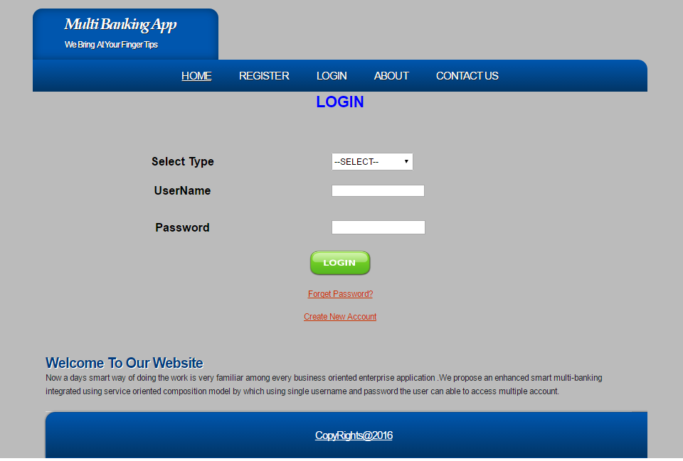
Fig: 8.4 Login Page

8.5 Customer Home Page:

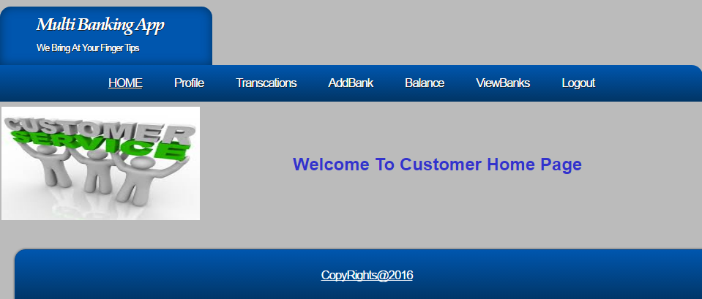
Fig: 8.5 Customer Home Page

8.6 Customers Profile

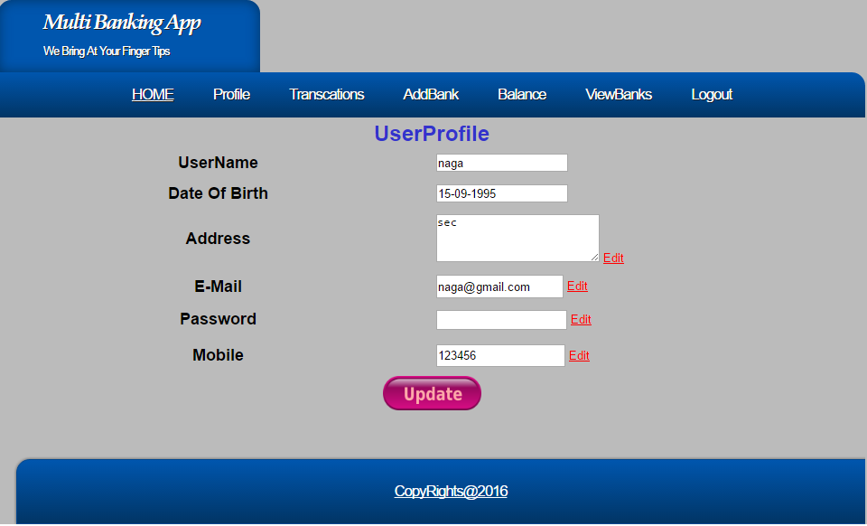

Fig: 8.6 Customer Profile

8.7 Customer Self Transaction Page

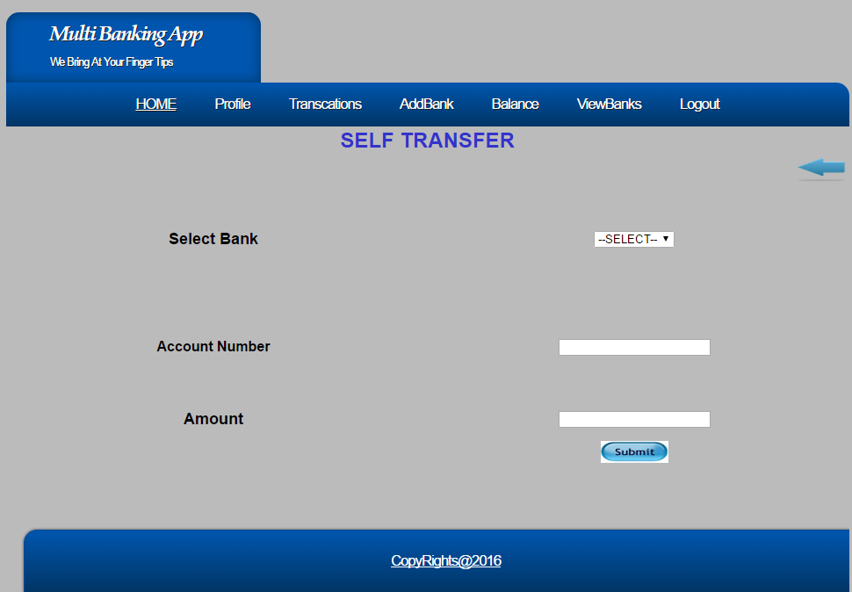

Fig: 8.7 Customer Self Transaction Page

8.9 Customer Transaction to Other Account Page

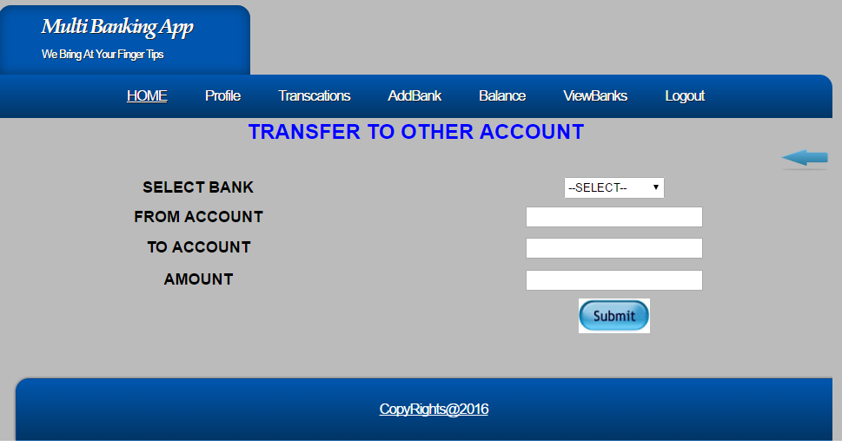

Fig: 8.9 Customer Transaction To Other Account Page

8.10 Add Bank Page

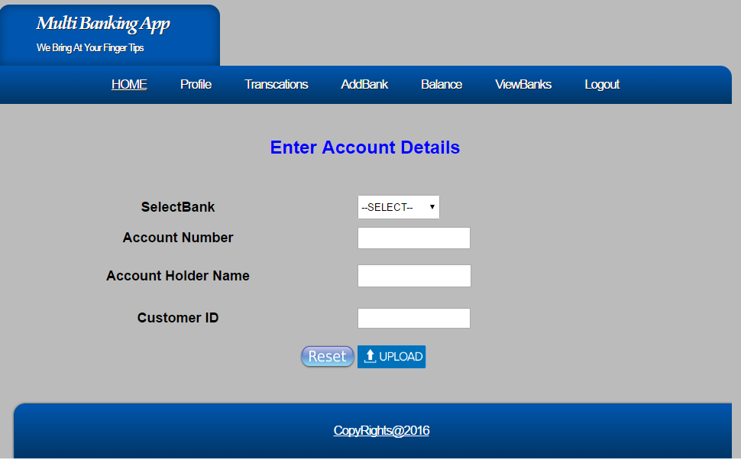

Fig: 8.10 Add Bank Page

8.11 Banker Home Page

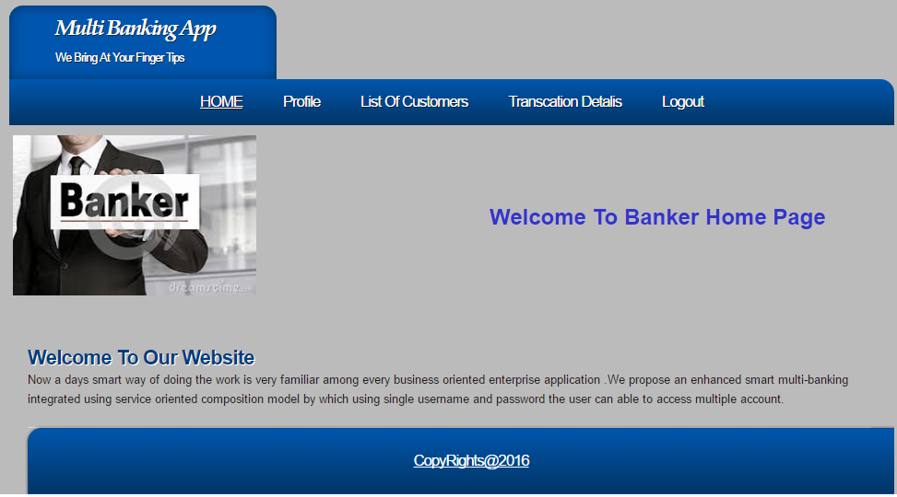

Fig: 8.11 Bank Home

8.12 Banker Profile Page

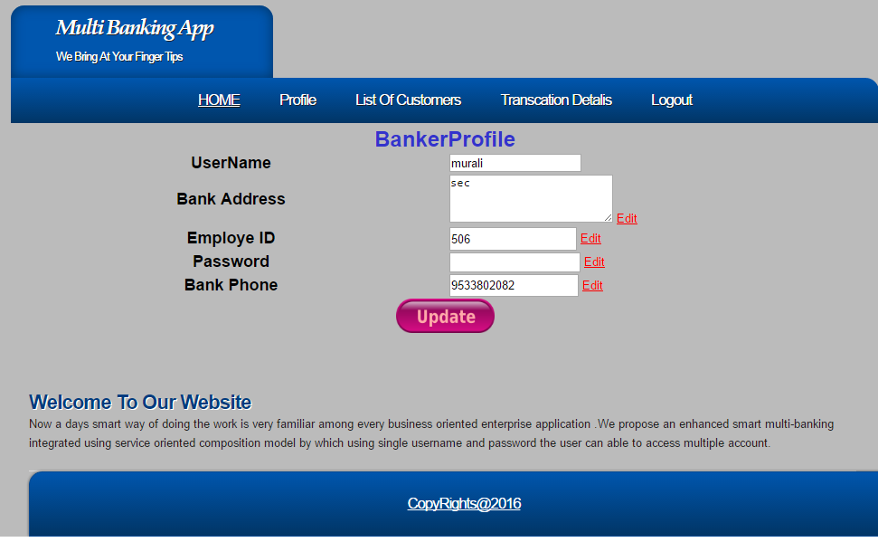

Fig: 8.12 Banker Profile

8.13 List of Customers Page

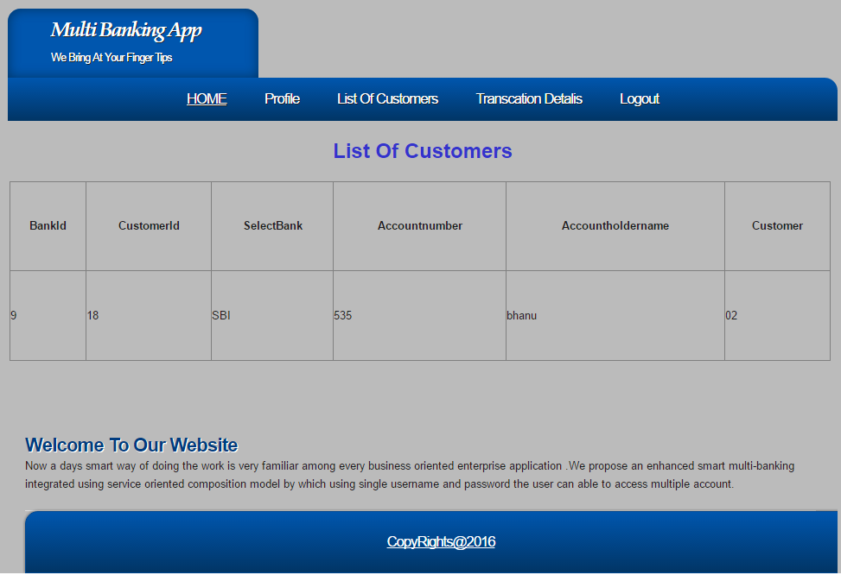

Fig: 8.13 List of customers

8.14 Transaction Details page
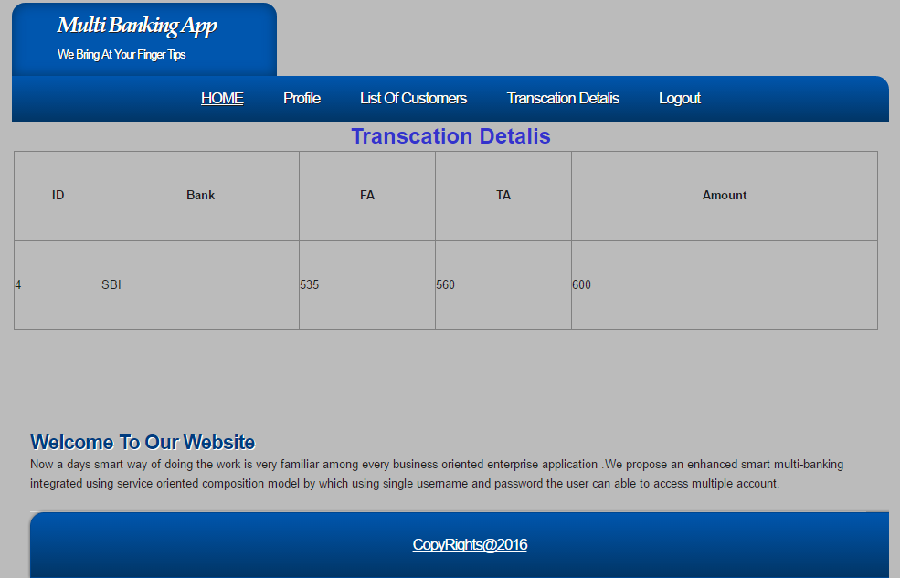

Fig: 8.14 Transaction Details

8.15 Admin Home Page

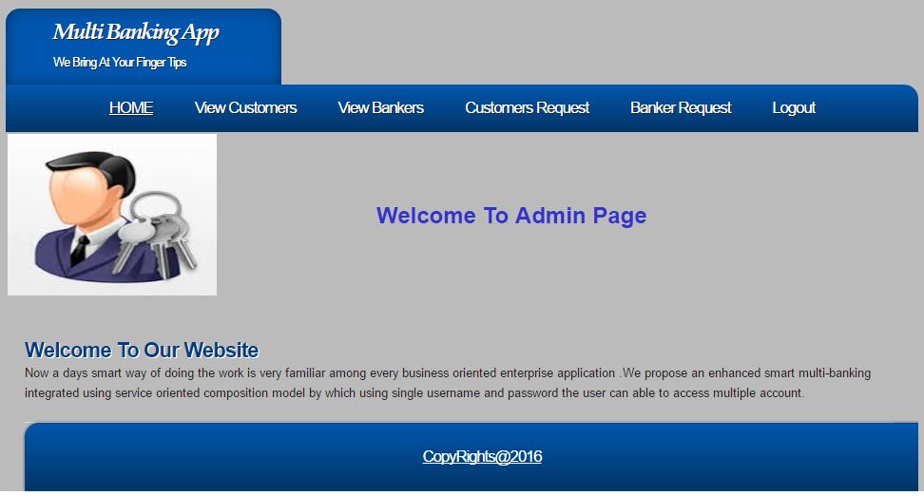

Fig: 8.15 Admin Home Page

8.16 List of Bankers Page

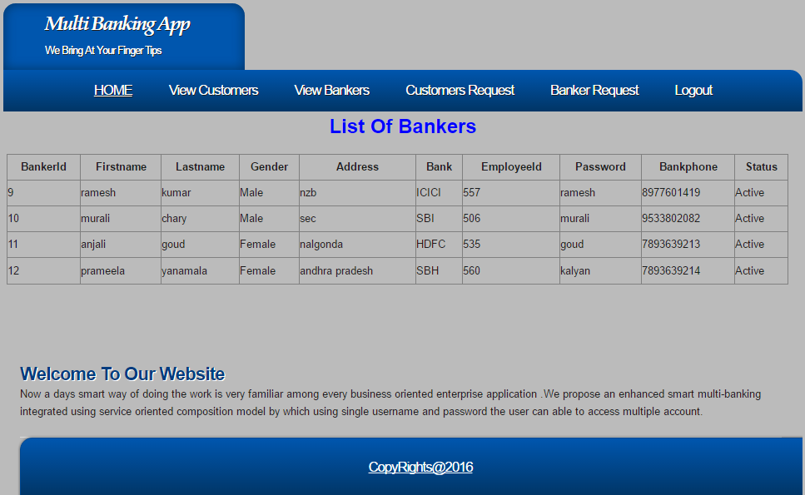

Fig: 8.16 List of Bankers

8.17 List of Customers Page

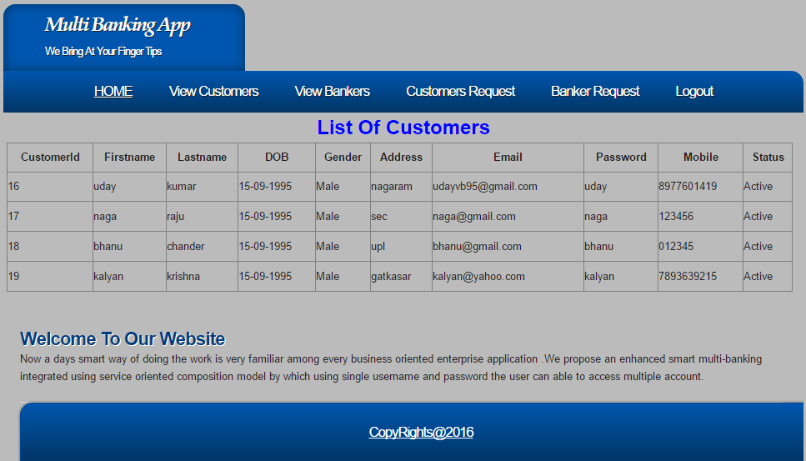

Fig: 8.17 List of Customers

8.18 Banker Request Page

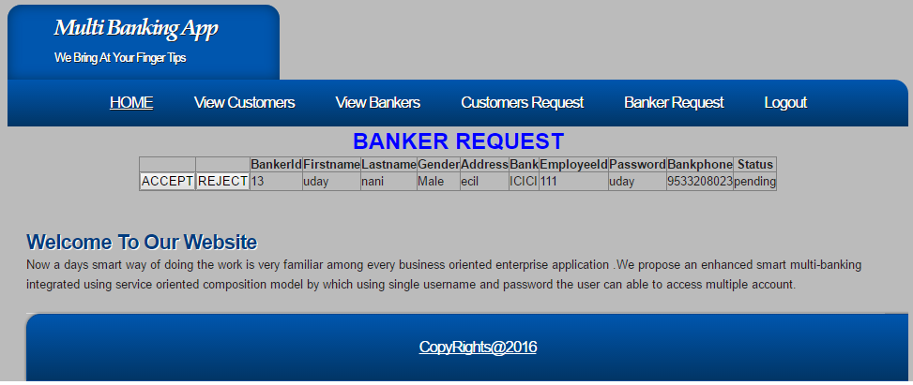

8.18 Banker Request

8.19 Customer Request Page

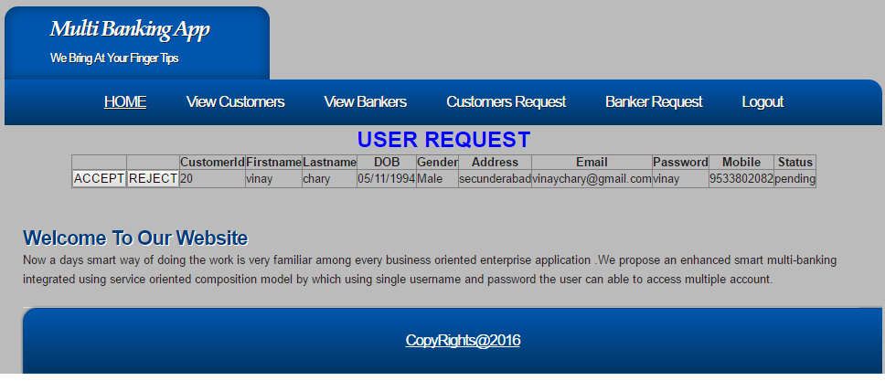 8.19 Customer Request

8.20 Contact Us Page

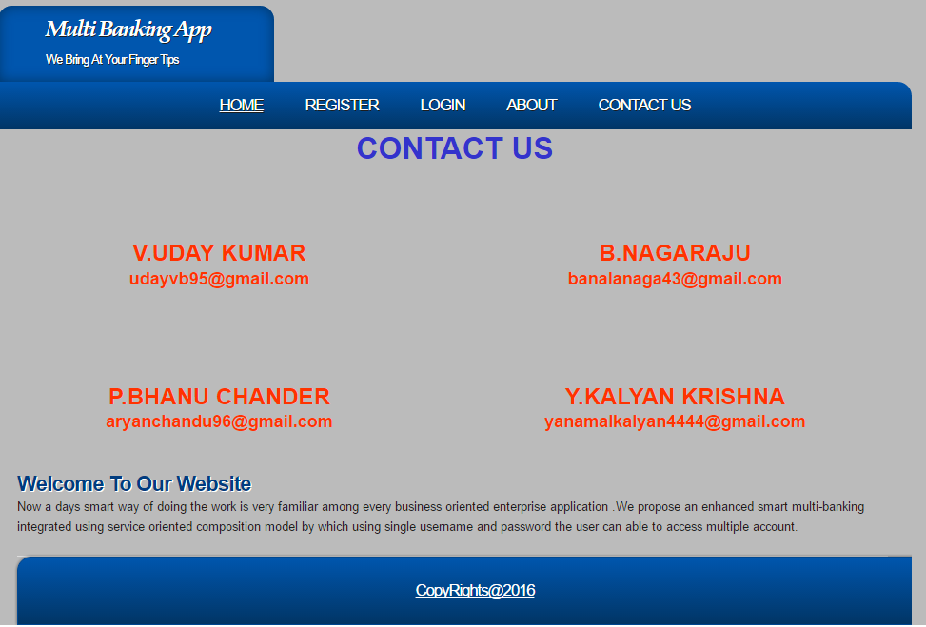
8.20 Contact Us

CONCLUSION
The Multi Banking Application for Banking which we have developed as a web application is very useful to Banking. This web application is developed with respect to the customer requirement, we had kept all our efforts to full-fill the customer and banker requirement. All the features which this software is giving are well checked and monitored by us. It is where well structured to give a feel that customer can easily satisfy with the result producing by the application.

SCOPE ANDFUTURE ENHANCEMENTS

The objective of this application to make the Customers of various Banks can do their account accessibility and transactions using this solution. They need not to interact with various applications or web sites of each bank. The Admin will add new Bank details and can update the existing details of the bank. The Admin will accept/reject the registration of a Customer to use this application.The Bank Admin makes access this site to see the all Customer transactions, account Transfer status, etc. He/she can accept or reject the fund transfer of the Customer. Should able to provide Response for the queries related to the Customers.The Customers should make request for multiple bank account access to the Administrator. He/she can view the Account related information. The customer should able to transfer the amount from one bank to another bank account using this system by providing the Secondary authentication details. The customer also facilitated to generate report for own bank details for a respective period. The Customer should able to send Queries to the Bank Admin.

10 BIBILIOGRAPHY
For .NET installation
www.support.microsoft.com
For deployment and packing on server
www.developer.com
www.15seconds.com
For SQL
www.msdn.microsoft.com
For ASP.NET
https://msdn.microsoft.com/en-IN/library/z1zx9t92.aspx
https://msdn.microsoft.com/enus/library/zw4w595w%28v=vs.110%29.aspx
https://msdn.microsoft.com/en-us/library/4w3ex9c2.aspx
Internet Drafts and RFCs
- DARPA RFC791, IP (Internet Protocol) http://www.ietf.org/rfc/rfc791.txt September 1981
- Simpson, W. RFC 1661 The Point-to-Point Protocol (PPP) http://www.cis.ohio-state.edu/cgi-bin/rfc/rfc1661.html July 1994
- Zorn, G. for Microsoft & Cobb, S. for Microsoft RFC 2433 MS CHAP version 1
http://www.ietf.org/rfc/rfc2433.txt October 1998
- Pall, G. for Microsoft and Zorn, G. for Cisco RFC 3078 MPPE (Microsoft Point to Point Encryption protocol) http://www.faqs.org/rfcs/rfc3078.html March 2001
- Pall, G. for Microsoft RFC 2118 MPPC (Microsoft Point to Point Compression protocol)
http://www.ietf.org/rfc/rfc2118.txt March 1997

